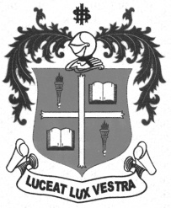
LOYOLA COLLEGE (AUTONOMOUS), CHENNAI – 600 034
M.A. DEGREE EXAMINATION - APPLIED HISTORY
FIRST SEMESTER – NOVEMBER 2012

HT 1810 - SOCIO-ECONOMIC & CULTURAL HISTORY OF MODERN T.N.

Date : 07/11/2012 Dept. No. Max. : 100 Marks

Time : 1:00 - 4:00

Part-A
Answer any FOUR of the following in 100 words each: (4x5=20 Marks)

- Twin Epics
- Wood’s Despatch
- Polygar System
- Nayangara system
- Muthulakshmi Reddy
- Mid-day Meal Scheme

Part-B
Answer any TWO of the following in 200 words each: (2x10=20 Marks)

- Explain the importance of Sangam Literature.
- Write a note on Bhakti Movement in Tamilnadu.
- Give a critical estimate of Thiru. C.N.Annadurai
- Trace the origin and the development of Anti-c aste movements in Tamnilnadu

Part-C

Answer any THREE of the following in 1200 words each: (3x20=60Marks)

- Describe the Socio-Economic and religious life of the Sangam Age.
- Enumerate the Educational reforms introduced by the British in India.
- What were the consequences of Industrialization and urbanization in Tamilnadu?
- Discuss the evaluation of Dravidian movement in the Madras state.
- Assess the contribution of Kamaraj as Chief Minister of Madras.

**********

